Kľúč k úlohám v PZ s. 74 - 77 (Family and Friends 2)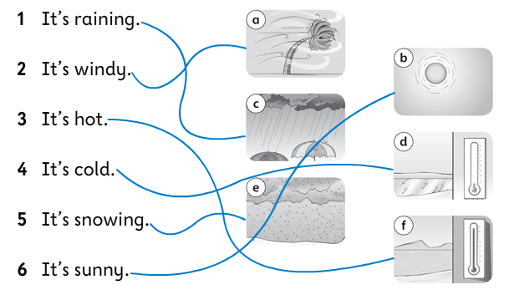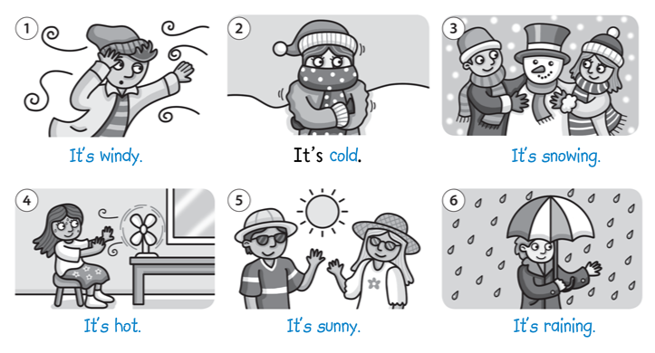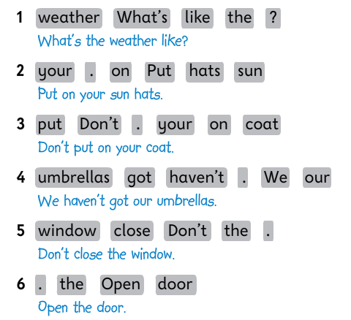
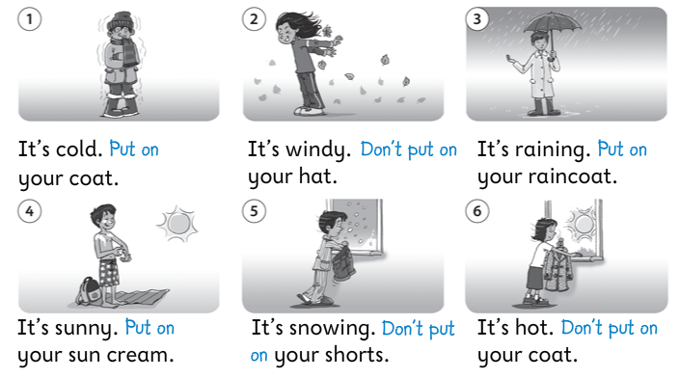
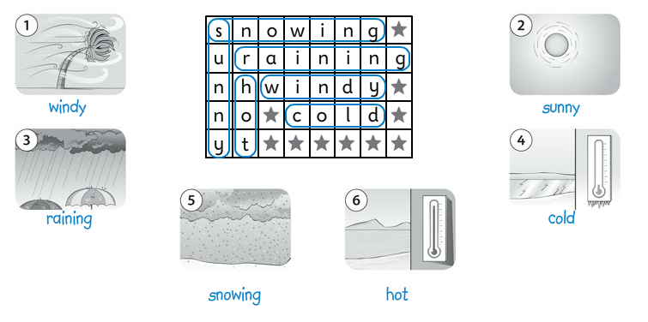
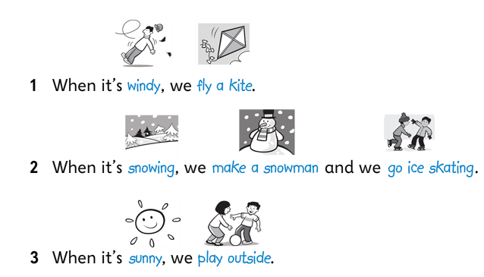
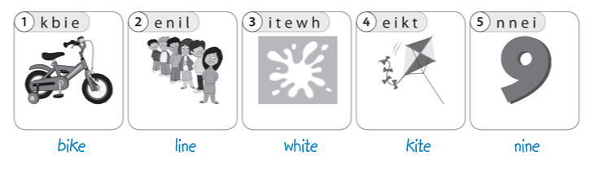
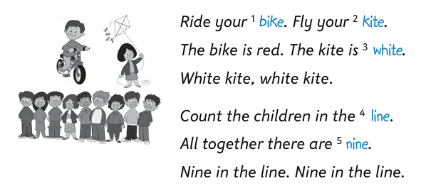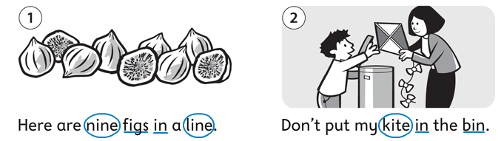
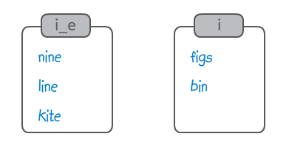
Kľúč k úlohám v malom zošite:
1/ Nájdené vety: What´s the weather like? Oh, no! Now it´s raining. My hat. Open the door, please! Where´s the key? Let´s go home. And we haven´t got our umbrellas. Put on your coat, Billy.
2/ Preklad:
It´s two o´clock in the afternoon.
It´s windy outside.
We play together in the park.
Mathew flies a kite.
Daisy doesn´t make a snowman.
They go outside.
What´s the weather like today?

